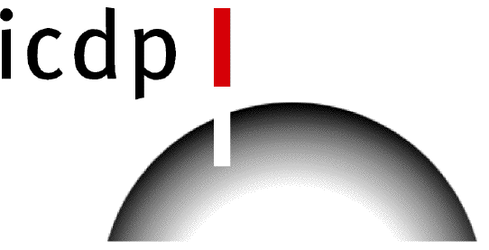

ICDP workshop on amphibious drilling to Investigate Miocene Mediterranean-Atlantic Gateway Exchange (IMMAGE), 22-24th November 2016, Rabat (Morocco)

APPLICATION FORM

First name:

Last name:

Institution:

Address:

e-mail:
Phone number:
Fax:

Fields of interest:

Brief description of your motivation to participate in the workshop (max. 200 words):

Please complete this form and email it to Rachel Flecker (r.flecker@bristol.ac.uk) by 9th September 2016

